Head to <https://restdb.io/>

Click the **Sign Up** link on the navbar and sign up for a free account

You will get a verification email in the inbox of the email you used to sign up, verify your account with **restdb** by clicking the **Verify Now**link that is provided in that email

You will be taken to this page upon verification:

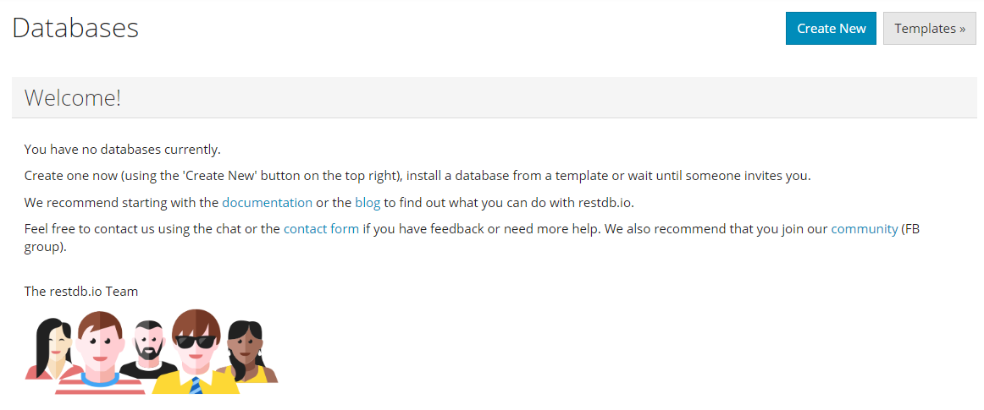

Click on the **Create New** button on the upper right to start creating your new database and you should see a modal prompting for a database name:

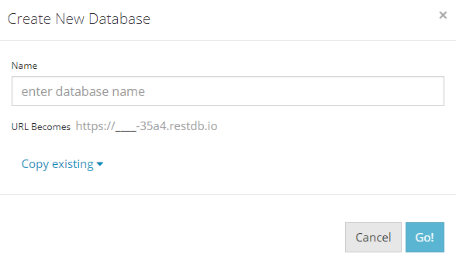

Enter a **custom name** for your new database, this will determine the **URL** you use to make the various **API requests** later. Once you’ve decided on a database name, click on the **Go!** Button

You should now see your database on the page. **Click into the database** and you will see the below dashboard page:

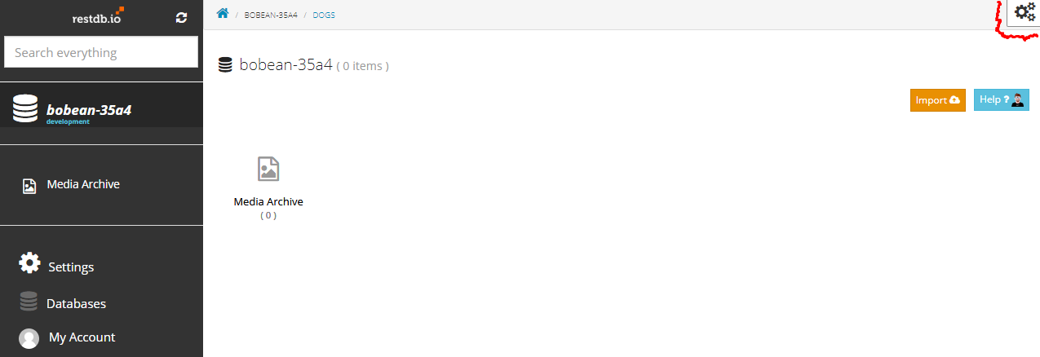

Click on the **gear icon** on the upper right of the screen to toggle on **developer mode**. This will take you to a screen that will allow you to import your **dogs.json** dataset into a table:

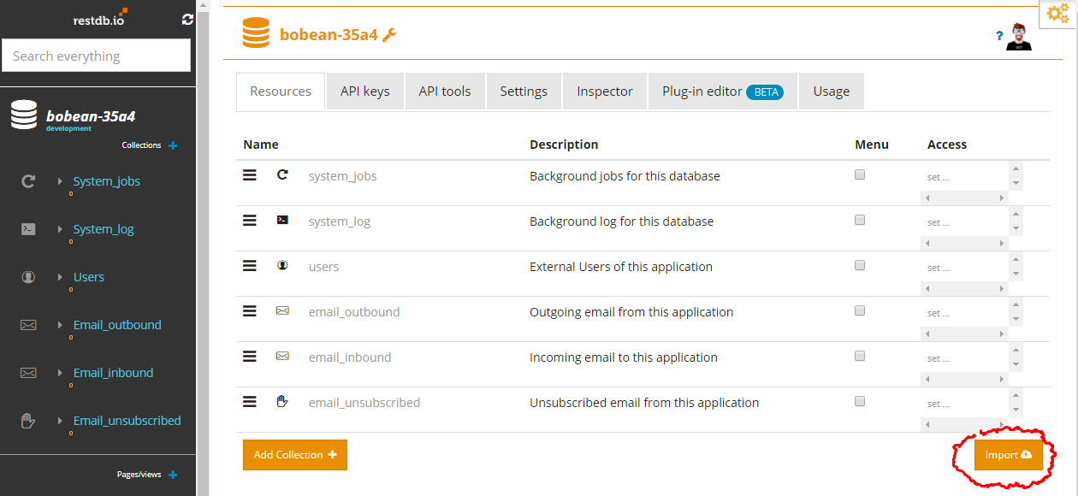

Click on the **Import** button to get to this screen:

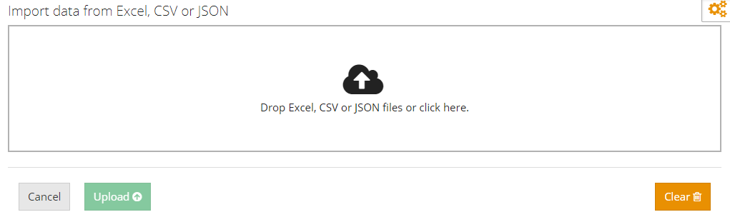

Upload the dogs.json file by dropping the JSON file into the designated box and click **Upload**

You will be taken to a screen that looks like this:

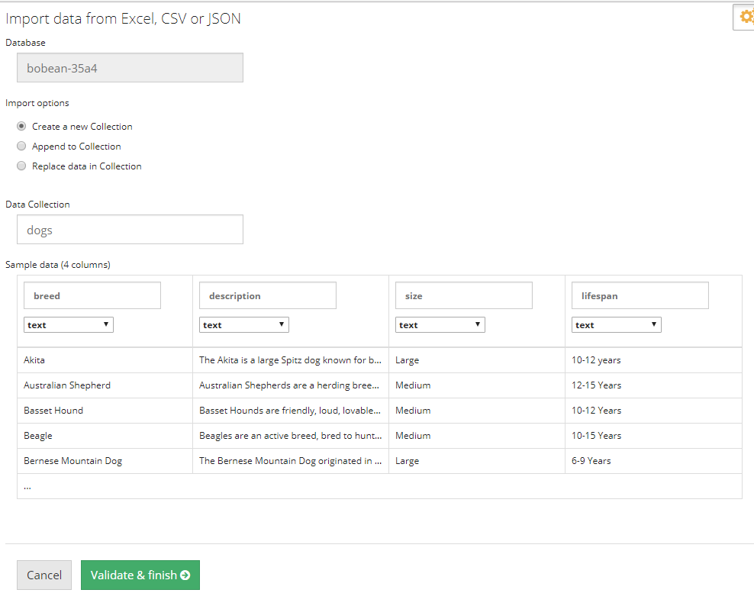

Click on **Validate & Finish** and the **dogs** table will be created in the database

Back on the dashboard screen, you should see the recently created dogs collection:

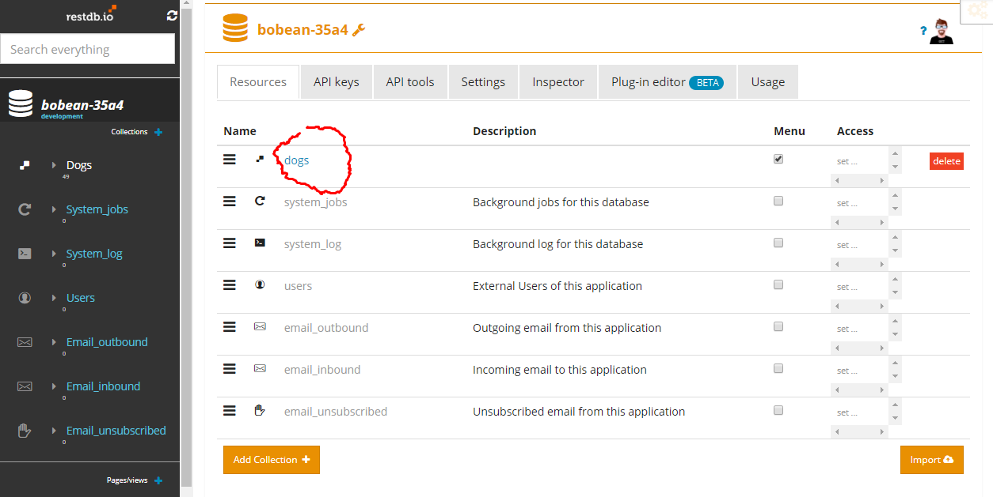

Click on the **dogs** link as circled above and you will be taken to the settings page for that specific collection:

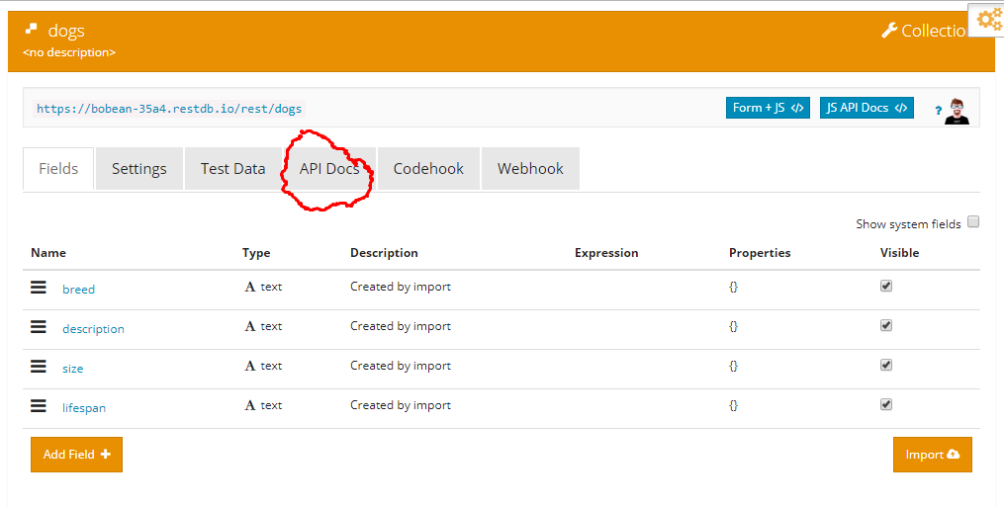

The **API Docs** page will have all the information you need to start making api requests to your newly created dogs table. Have fun.